# [SETTING UP APPLICATION ENVIRONMENT](https://careereducation.smartinternz.com/Student/guided_project_workspace/24165)

|  |  |
| --- | --- |
| Date | 31 October 2022 |
| Team ID | PNT2022TMID51918 |
| Project Name | Project - Personal Expense Tracker  Application |

**Install IBM Cloud CLI**

Install IBM CLI on your laptops by following the reference link.

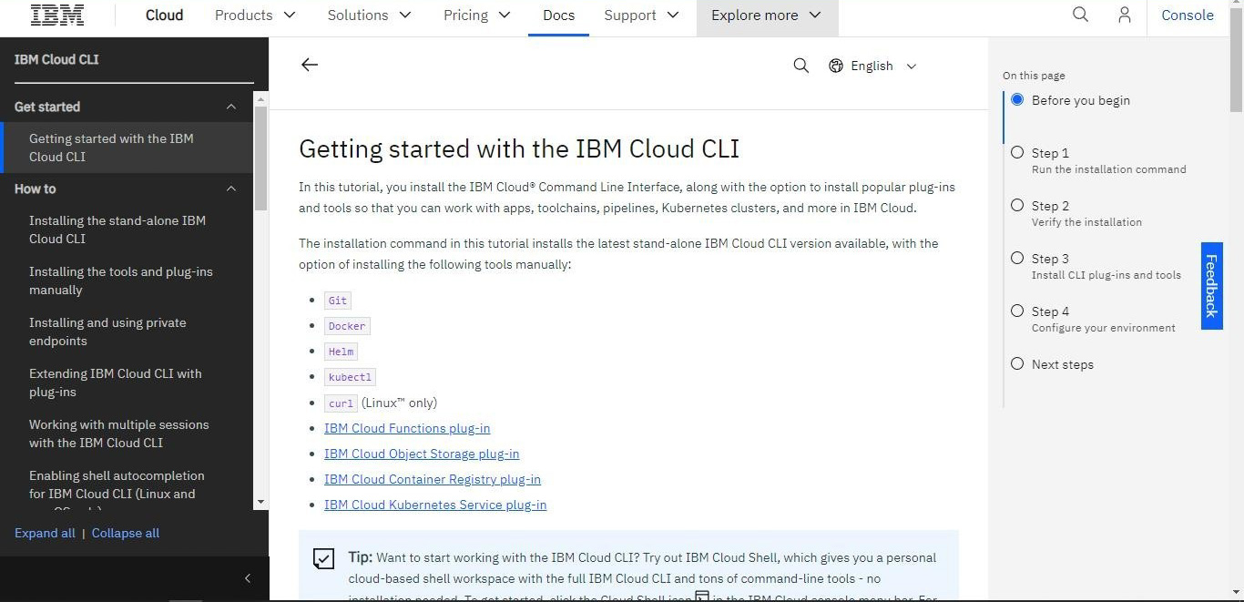

# Step 1: Run the installation command

The latest version of the IBM Cloud CLI is installed when you run the command. As the CLI installs, keep an eye on the command line to authenticate as needed.

For Windows™ 10 Pro, run the following command in PowerShell as an administrator:

iex (New-Object Net.WebClient).DownloadString('https://clis.cloud.ibm.com/ins tall/powershell')

# Step 2: Verify the installation

To verify that the CLI was installed successfully, run

the command:

help

ibmcloud help

The output lists the usage instructions, the current version, and the supported commands.

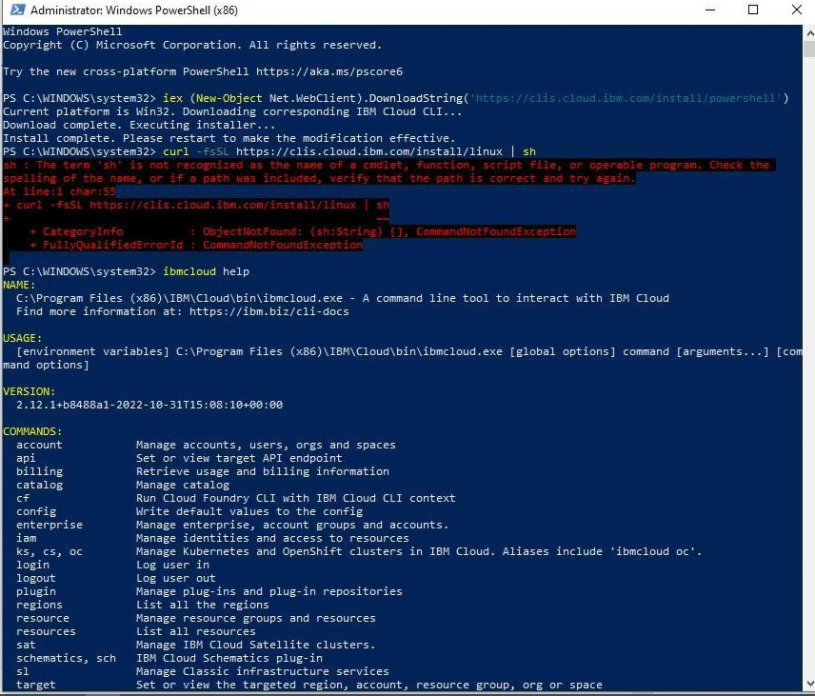

# Step 3: Install CLI plug-ins and tools

To manually install the CLI plug-ins and tools, see [installing the](https://cloud.ibm.com/docs/cli?topic=cli-install-devtools-manually) tools and plug-ins manually.

# Step 4: Configure your environment

.

Log in to IBM Cloud with your IBMid. If you have multiple accounts, you are prompted to select which account to use. If

-r

you do not specify a region with the select a region.

flag, you must also

ibmcloud login

